What is a School-Parent Compact?  Our annual school-parent compact is a written commitment describing how all members of a school community—parents, teachers, principals, and students—agree to share responsibility for student learning. This compact helps bridge the learning connection between school and home.  jointly developed  This compact is uniquely developed to meet the needs and goals of our students. Parents, students, teachers and faculty member’s work together to develop our school-parent compact. Each school year, two meetings are held for parents, teachers, and students to compare the compact with school data to review our progress and assess our goals. |  | parent outreach opportunities  There are many opportunities for parents to learn about and engage with H.L. “Hank” Aaron New Beginnings Academy. Please contact our school to learn about these great opportunities and more.  - School Events: Open House, Parent Workshops, Fall and Spring Title I Meetings, Information Day, Curriculum Night, etc.  - Parent Volunteers: Parents are welcome to volunteer in classrooms, especially reading and mathematics.  - Parent Teacher Student Conferences*  - Classroom Visits and Observations*  Parents may schedule conferences, classroom visits, and observations at any time by emailing the teacher or calling the school.  Parent Center Contact and Hours  Monday-Friday 10:00am -4:00 pm  Mrs. Mamie Jackson at  mpjackson@atlanta.k12.ga.us  404-802-6961  connect with us!  2930 Forrest Hill Drive  Atlanta, GA 30315  (404)802-6953  Website  www.atlantapublicschools.us/fha  Social Media  Mrs. Jackson-H.L. “Hank” Aaron New Beginnings Academy Webpage   |  | Henry Louis ”Hank” Aaron New Beginnings Academy  Grades 9-12  School-Parent Compact  2022-2023  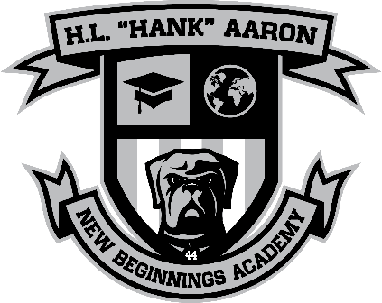
  School and Home  Communication  H.L. “Hank” Aaron New Beginnings Academy is committed to providing regular two-way communication With families about student learning. Some of the ways families can expect us to reach out are:  - Parent Portal  - School Web site  - Six-week progress reports  - Parent Liaison Newsletter  - Telephone messages  - Parent-teacher conferences  - Robo-Calls  - Email, Twitter, etc.  - Zoom Meetings (virtual platform) |  |  |  | “Learn, Grow, Evolve”  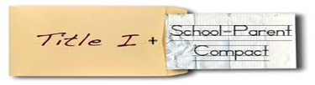  Zawadaski L. Robinson, Ed. D, Principal  Sherri J. Johnson, Assistant Principal  Christopher D. Reese, Assistant Principal  Maurice Harrison, Assistant Principal  Revised: May 26, 2022
academic goals  APS Mission  Through a caring culture of equity, trust, collaboration, every student will graduate ready for college, career, and life.  APS Vision  A high-performing school district where students love to learn, educators inspire, families engage, and the community trust the system.  School Goals  Collectively we will cultivate strong students, a strong staff, and a stronger community. Forrest Hill Academy will continuously transform into a non-traditional, student-centered school that empowers student development in academics, social emotional learning, college and career readiness, and community outreach.  Highlighted below are 2 goals extracted from our school wide plan:  - Math  - Reading  H.L. “Hank” Aaron New Beginnings Academy students will…….  - Demonstrate academic growth.  - Become more self-aware and repair harm.  - Make responsible decisions.  - Improve relationship skills  - Improve self-management skills     |  | TEACHERS & STAFF  On H.L. “Hank” Aaron New Beginnings Academy’s campus and in classrooms Teachers and Staff will:  - Provide students and parents with a “Writer’s Checklist” and APA standards to assist them with the essential elements of standard writing and spoken English.  - Provide high quality instruction in a supportive and effective learning environment that enables students to meet the State’s student achievement standards.  - Provide high quality curriculum and instruction in a supportive and effective learning environment.  - Provide feedback to students and parents in a timely manner and posting this feedback in Infinite Campus to help guide students’ home learning  SCHOLARS  At home and at school H.L. “Hank” Aaron New Beginnings Academy Students will:  - Learn the Georgia Performance Standards to the best of my ability  - Complete assignments and turn them in on time  - Obey the school and bus rules to insure a positive learning environment  - Attend school regularly and be in class on time  - Enter class prepared with all materials needed and with a positive attitude about learning  - Follow my Individual Graduation Plan (IGP) and take advantage of test  - Communicate with my parents/guardians about my learning goals at school and upcoming events that support me to be academically successful.  FAMILIES  At home and in the community H.L. “Hank” Aaron New Beginnings Academy Parents and Families will:  - Insure my child studies and practices Math every night during the semester(s) the student is enrolled in a Math course in order to master standards.  - Check my child’s progress by attending parent-teacher conferences, discussing progress reports and report cards, and checking grades and attendance (where internet access is available).  - Check to make sure my child is attending school regularly  - Support my child to follow school rules as not to interrupt the delivery of instruction.  - Communicate with my child’s counselor about future college and career ready planning.

